Project Dashboard and Story

Dashboard Overview
Use this full dashboard screenshot on the dashboard overview/final output page. It showcases the completed interactive dashboard.
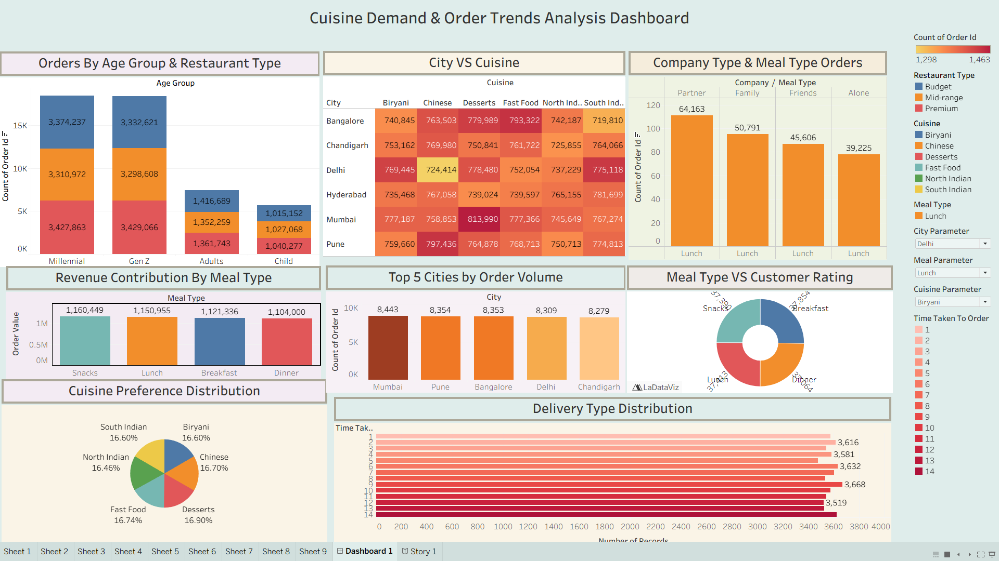

Delivery Type Distribution
Use this where the template asks for the Delivery Type/individual visualization. Explain that it displays the distribution of orders across delivery time values using Number of Records.
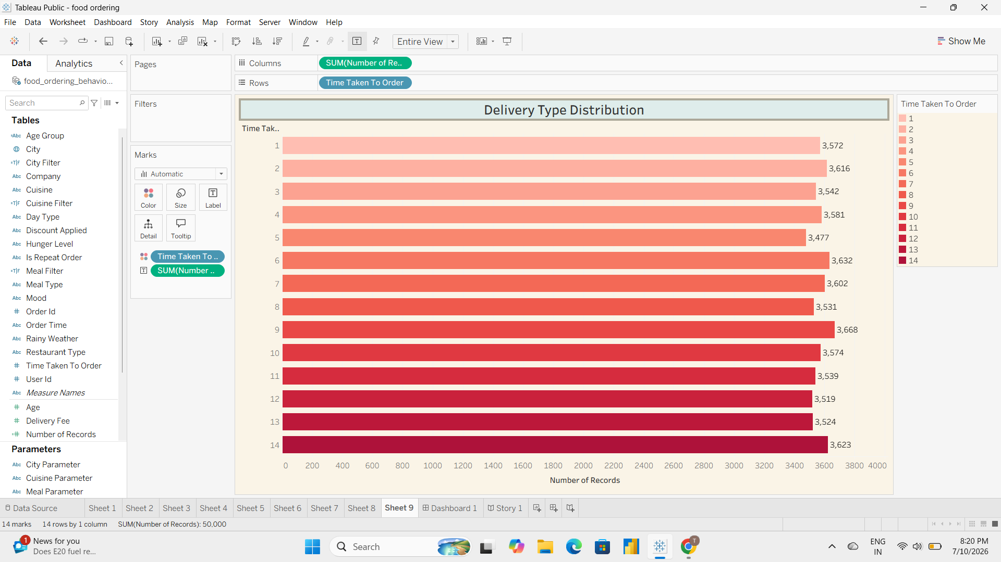

Revenue Contribution by Meal Type
Use this in the Results/Visualizations section. Mention it compares total revenue generated by Breakfast, Lunch, Dinner and Snacks.
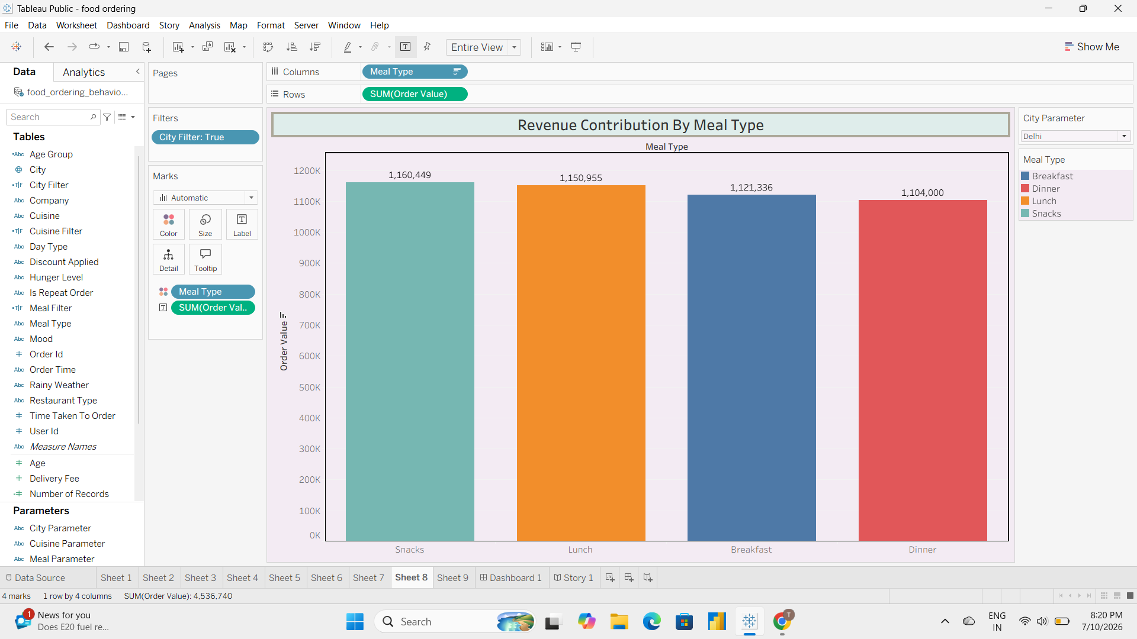

Top 5 Cities by Order Volume
Place this in the City Analysis section. Explain that it identifies the five cities with the highest order counts.
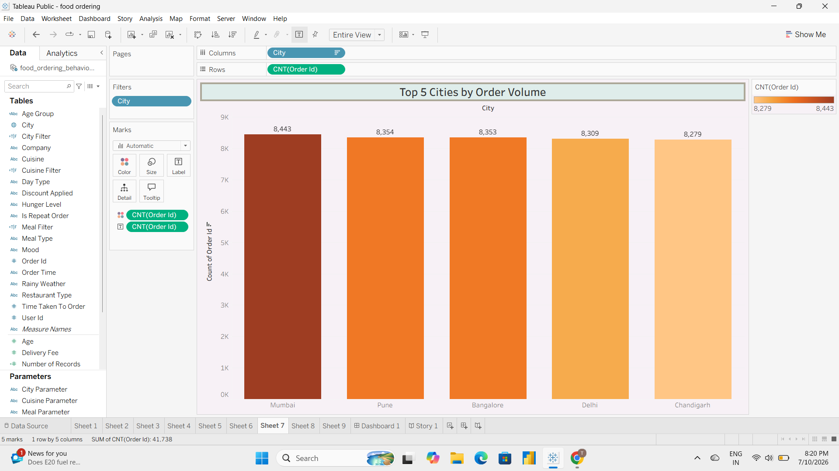

Meal Type vs Customer Rating
Insert this in the Customer Insights section. Explain that it compares customer ratings across meal types using a donut chart.
